LAB EXPERIMENT RECORD

Department | AI&DS
Course Code / Course Name | DSA0602 / Data Handling and Visualization
Experiment | Data Visualization using R
Name | M.Teja kumar
Register Number | 192424308
Date | 3 October 2026
Day | Saturday

SET 9: ONLINE LEARNING ACTIVITY

Aim
To analyse online learning activity data using a histogram, boxplot, bubble scatter plot, and monthly trend line in R, and to build an interactive dashboard in Tableau.
Dataset: Online_Learning_Activity.csv

Student_ID | Gender | Age | Course | Study_Time (hrs) | Videos_Watched | Quiz_Score | Login_Date
L01 | Male | 20 | R | 3.5 | 12 | 78 | 2025-01-05
L02 | Female | 22 | R | 4.2 | 15 | 85 | 2025-01-05
L03 | Male | 19 | SQL | 2.0 | 8 | 65 | 2025-02-08
L04 | Female | 21 | R | 5.0 | 18 | 92 | 2025-02-08
L05 | Male | 23 | R | 2.5 | 9 | 70 | 2025-03-12
L06 | Female | 20 | SQL | 4.0 | 14 | 88 | 2025-03-12

PROGRAM 1: Histogram and Boxplot of Quiz Score
Import the dataset in R. Plot a histogram for Quiz_Score. Draw a boxplot of Quiz_Score by Course. Add title and labels. Interpret student performance.
# Import the dataset
learning <- read.csv("Online_Learning_Activity.csv")

# Histogram of Quiz_Score hist(learning$Quiz_Score,
breaks = seq(60, 100, by = 10), main = "Histogram of Quiz Score", xlab = "Quiz Score",
ylab = "Frequency", col = "skyblue")
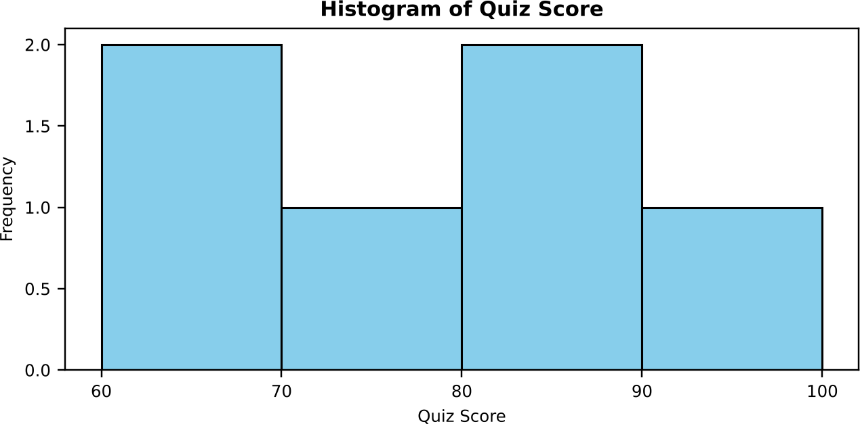

Output 1: Histogram of Quiz Score
# Boxplot of Quiz_Score by Course boxplot(Quiz_Score ~ Course, data = learning,
main = "Quiz Score by Course", xlab = "Course",
ylab = "Quiz Score",
col = c("skyblue", "lightgreen"))
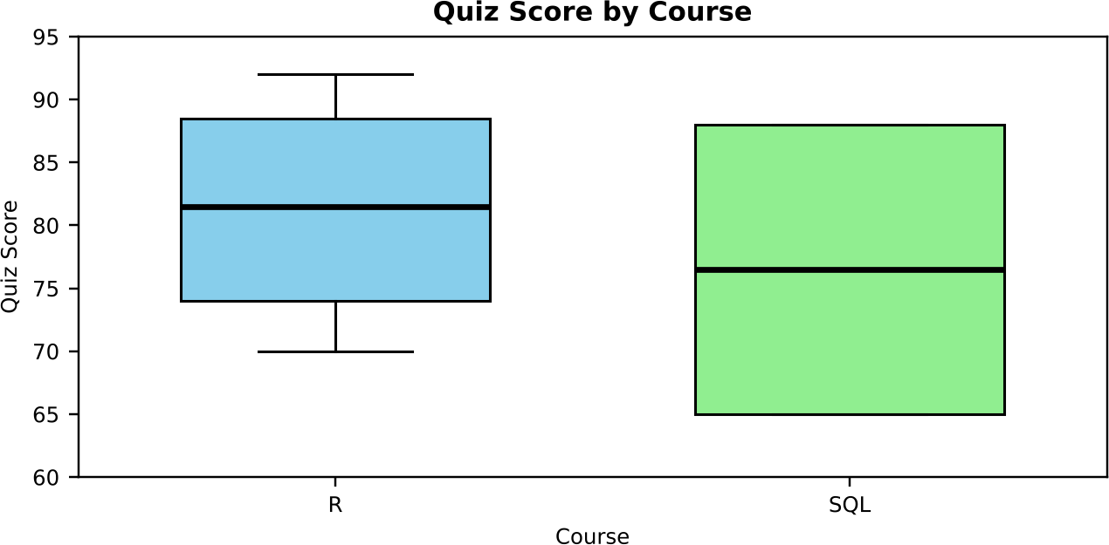

Output 2: Boxplot of Quiz Score by Course
Interpretation: The quiz scores range from 65 to 92, with a mean of 79.7 and a median of 81.5. The histogram has two peaks, at 60-70 and at 80-90 (two students each), so the class splits into a lower-scoring and a higher-scoring group. In the boxplot, R has the higher median (81.5) and the highest score (92), while SQL has a lower median (76.5) and a wider spread (65 to 88). Only two students took SQL, so this comparison is an indication rather than a firm conclusion.

PROGRAM 2: Bubble Scatter Plot of Study Time vs Quiz Score
Create a scatter plot using R programming between Study_Time and Quiz_Score. Represent Videos_Watched using bubble size. Apply transparency. Explain the learning pattern.
library(ggplot2)

# Bubble chart: bubble size = Videos_Watched, transparency = 0.6 ggplot(learning, aes(x = Study_Time, y = Quiz_Score, size = Videos_Watched)) +
geom_point(alpha = 0.6, colour = "steelblue") + scale_size(range = c(4, 14)) +
labs(title = "Study Time vs Quiz Score (bubble size = Videos Watched)", x = "Study Time (hrs)",
y = "Quiz Score",
size = "Videos_Watched")

# Strength of the relationship cor(learning$Study_Time, learning$Quiz_Score)
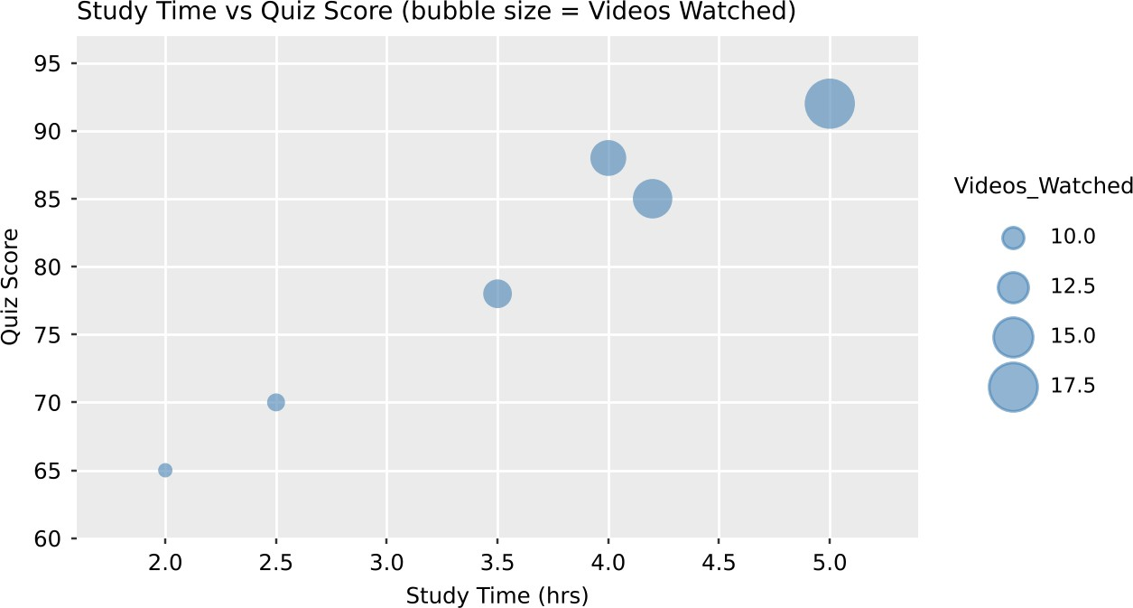

Output 3: Study Time vs Quiz Score Bubble Plot
Learning pattern: The points rise from the lower left to the upper right, and the correlation coefficient is about 0.98, a very strong positive relationship. Students who study longer also score higher. The bubbles also grow larger toward the top right: L04 studied 5.0 hours, watched 18 videos, and scored 92, while L03 studied 2.0 hours, watched 8 videos, and scored 65. So more study time and more videos watched go together with better quiz scores. With only six students this shows a pattern but does not prove cause.

PROGRAM 3: Monthly Average Quiz Score with Moving Average
Using R programming, convert Login_Date into Date format. Calculate the average quiz score per month. Plot a line chart. Apply moving average smoothing. Identify the trend.
# Convert Login_Date to Date format and extract the month learning$Login_Date <- as.Date(learning$Login_Date, format = "%Y-%m-%d") learning$Month <- format(learning$Login_Date, "%Y-%m")

# Average quiz score per month
monthly <- aggregate(Quiz_Score ~ Month, data = learning, FUN = mean)

# 2-month moving average (smoothing)
monthly$Moving_Avg <- as.numeric(stats::filter(monthly$Quiz_Score, rep(1/2, 2), sides = 1)) print(monthly)

# Line chart with the moving average
plot(1:3, monthly$Quiz_Score, type = "o", col = "blue", xaxt = "n", xlab = "Month", ylab = "Average Quiz Score",
main = "Average Quiz Score per Month", ylim = c(76, 84)) axis(1, at = 1:3, labels = monthly$Month)
lines(1:3, monthly$Moving_Avg, type = "o", col = "red", lty = 2, pch = 15) legend("topright", legend = c("Monthly average", "2-month moving average"),
col = c("blue", "red"), lty = c(1, 2), pch = c(1, 15))

Month | Quiz_Score (Average) | Moving_Avg
2025-01 | 81.50 | NA
2025-02 | 78.50 | 80.00
2025-03 | 79.00 | 78.75

Output 4: Monthly Average Quiz Score Table
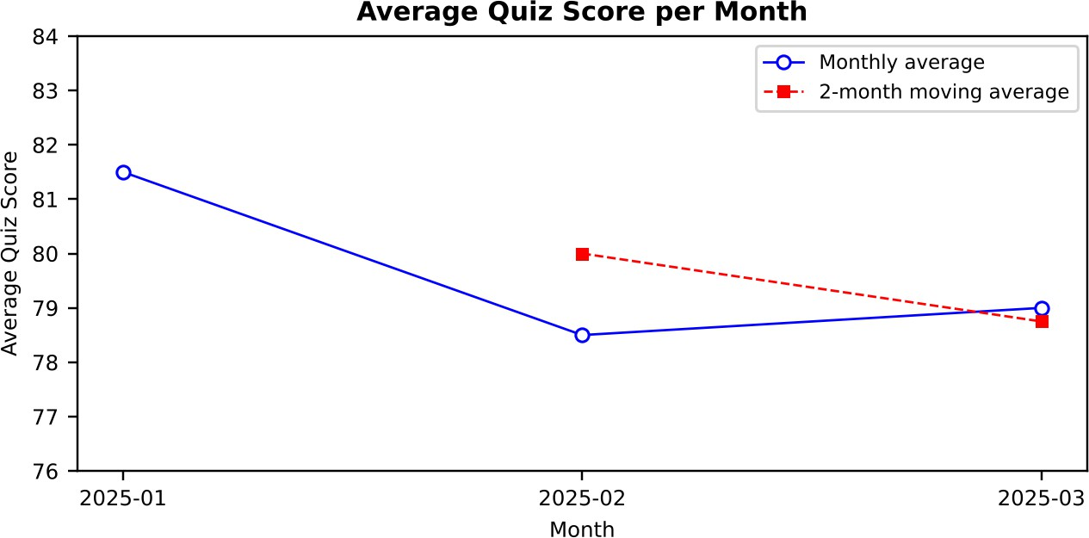

Output 5: Average Quiz Score per Month with Moving Average

Trend: The average quiz score falls from 81.50 in January to 78.50 in February and recovers slightly to 79.00 in March. The moving average declines from 80.00 to 78.75, so the overall trend is a small downward movement of about 2.5 points over the three months.

PROGRAM 4: Tableau Dashboard for Online Learning Activity
Import Online_Learning_Activity.csv into Tableau. Create a bar chart showing average quiz score by course, a scatter plot (Study Time vs Quiz Score), and add a filter for Gender and Course. Design a mini interactive dashboard.

Steps in Tableau:
- Open Tableau, choose Connect > Text file, and load Online_Learning_Activity.csv. Make sure Login_Date is set to the Date data type.
- Sheet 1 (Bar Chart): drag Course to Columns and Quiz Score to Rows, and change the aggregation to AVG. Choose the Bar mark type, drag Course to Color, and title the sheet "Average Quiz Score by Course".
- Sheet 2 (Scatter Plot): drag Study Time to Columns and Quiz Score to Rows. Drag Student ID to Detail so that each student is shown as a point, and drag Course to Color. Title the sheet "Study Time vs Quiz Score".
- Right-click Gender in the Data pane and choose Show Filter. Do the same for Course. For each filter, choose Apply to Worksheets > Selected Worksheets and select both sheets.
- Create a new Dashboard, drag Sheet 1 and Sheet 2 onto it, and arrange them side by side with the Gender and Course filters at the right.
- For interactivity, select "Use as Filter" on the bar chart so that clicking a course updates the scatter plot.
- Title the dashboard "Online Learning Dashboard" and save the workbook.
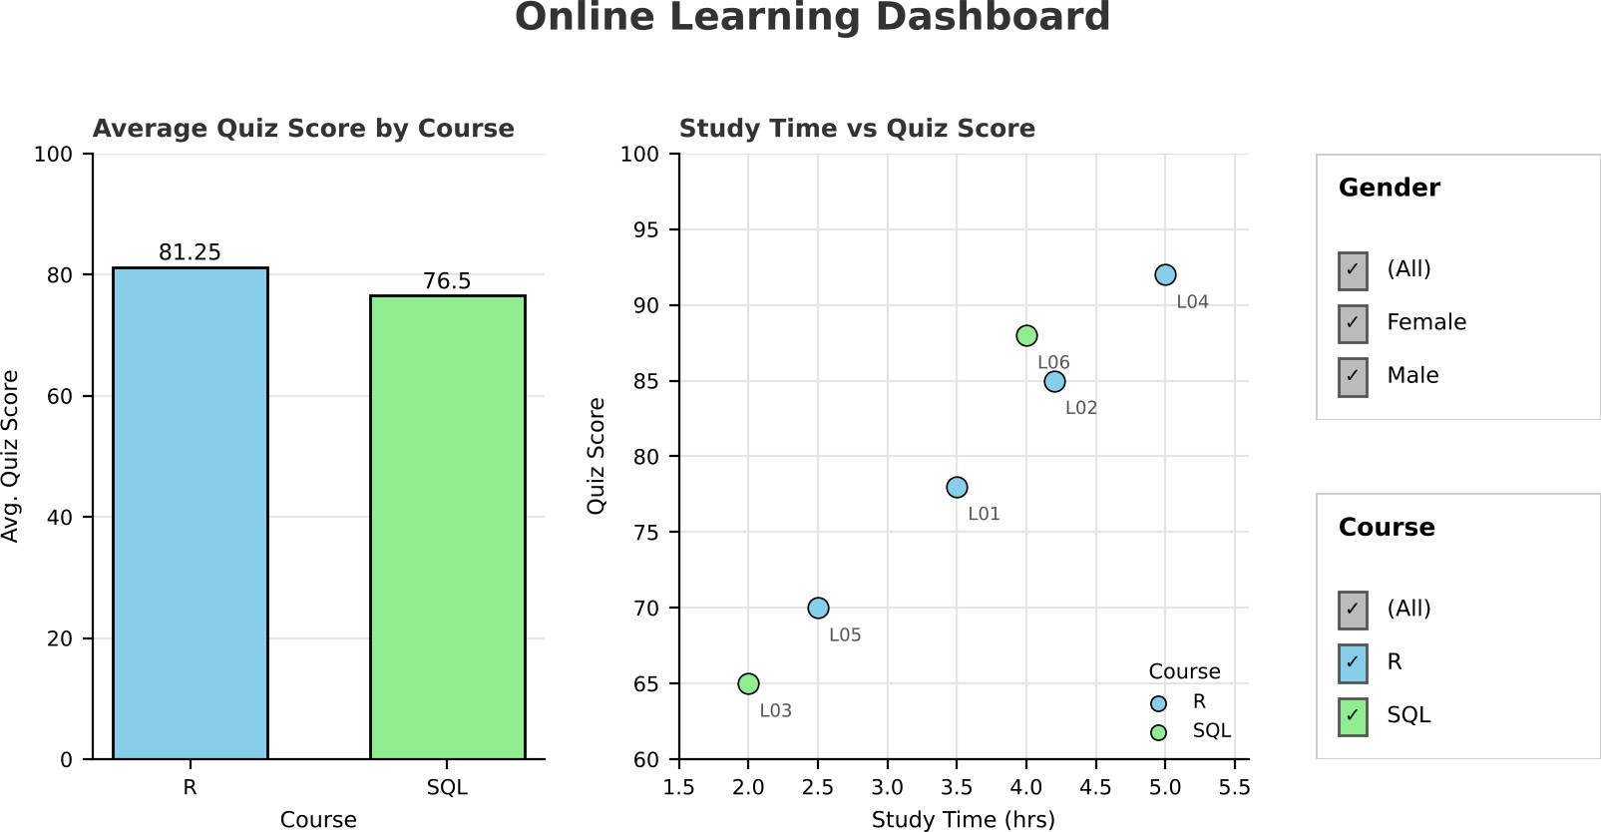

Output 6: Online Learning Activity Tableau Dashboard
Observation: The dashboard shows the average quiz score for each course next to the study time and score of every student. Changing the Gender or Course filter, or clicking a bar, updates both views, so users can explore the learning activity interactively.

Set 9 Procedure
- Import the dataset with read.csv() and view its columns.
- Use hist() for the histogram and boxplot() with a formula (Quiz_Score ~ Course) for the boxplot by course.
- Use ggplot() with geom_point(alpha = 0.6) and size = Videos_Watched for the bubble scatter plot, and cor() to measure the relationship.
- Convert Login_Date with as.Date(), find the monthly average with aggregate(), smooth it with stats::filter(), and draw the line chart with plot() and lines().
- Import the CSV file in Tableau, build the bar chart and scatter plot, add Gender and Course filters, and combine them in a dashboard.

Set 9 Result
The online learning activity data was successfully analysed in R using a histogram, boxplot, bubble scatter plot, and a monthly average line chart with moving average smoothing. A Tableau dashboard with a bar chart, a scatter plot, and Gender and Course filters was created for interactive exploration.

Key Functions Used

Function / Tool | Purpose
read.csv() | Imports the dataset from the CSV file.
hist() / boxplot() | Create the histogram and the boxplot by course.
ggplot() + geom_point() | Creates the bubble scatter plot with transparency.
cor() | Calculates the correlation coefficient.
as.Date() / format() | Convert Login_Date and extract the month.
aggregate() | Calculates the average quiz score per month.
stats::filter() | Calculates the moving average.
Tableau Dashboard | Combines sheets with filters for interactive exploration.

